# Binary Model No Embeddings.

* **Decision Plot**

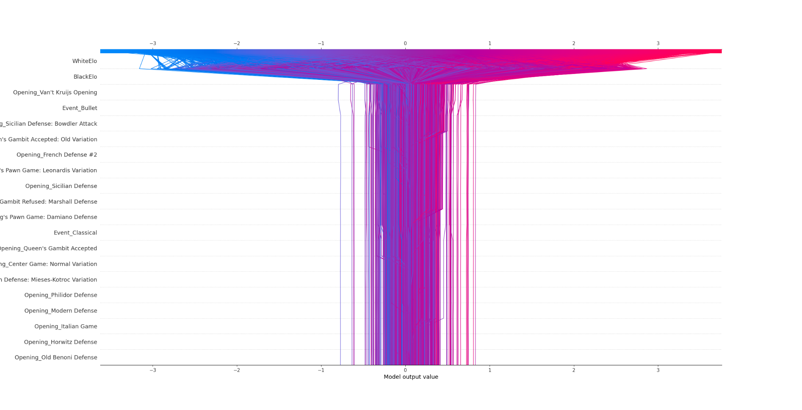

* **Bar plot**

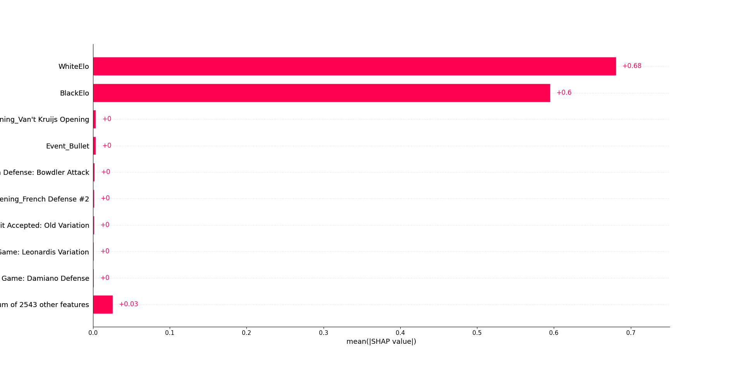

* **Scatter Plot Dependence**

# Binary Model

* **Confusion Matrix**

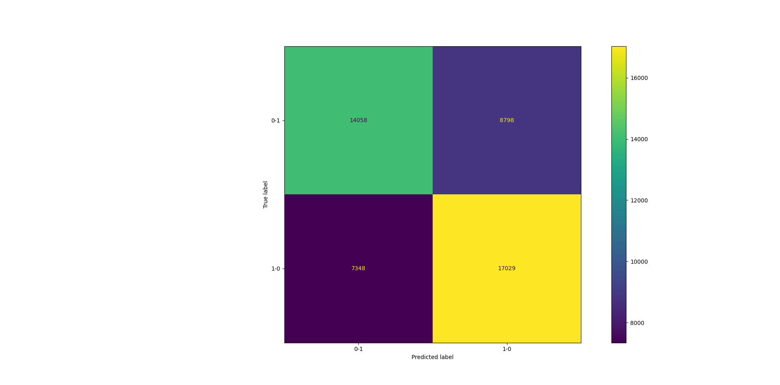

* Decision Plot

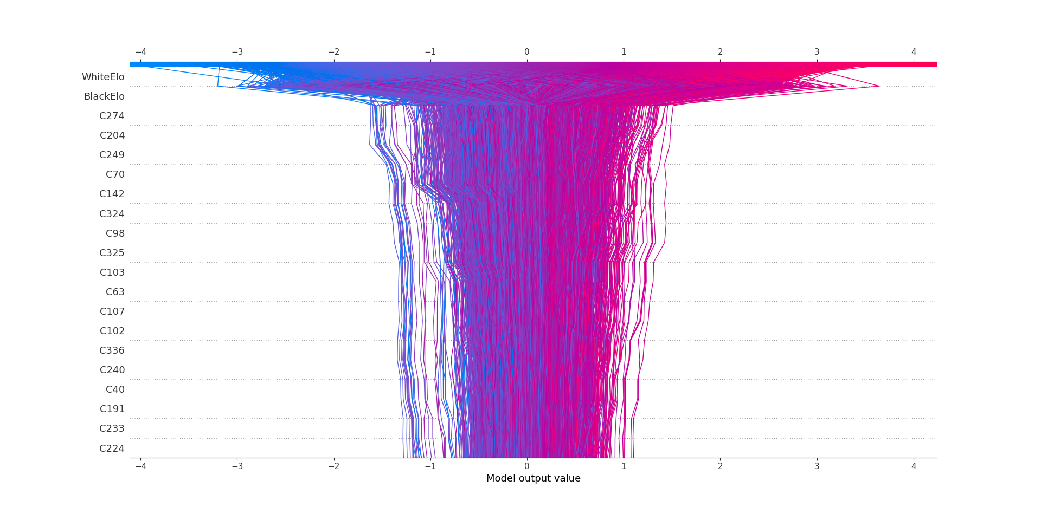

* Summary Plot

# 

* Scatter Dependence Plot BlackELO:

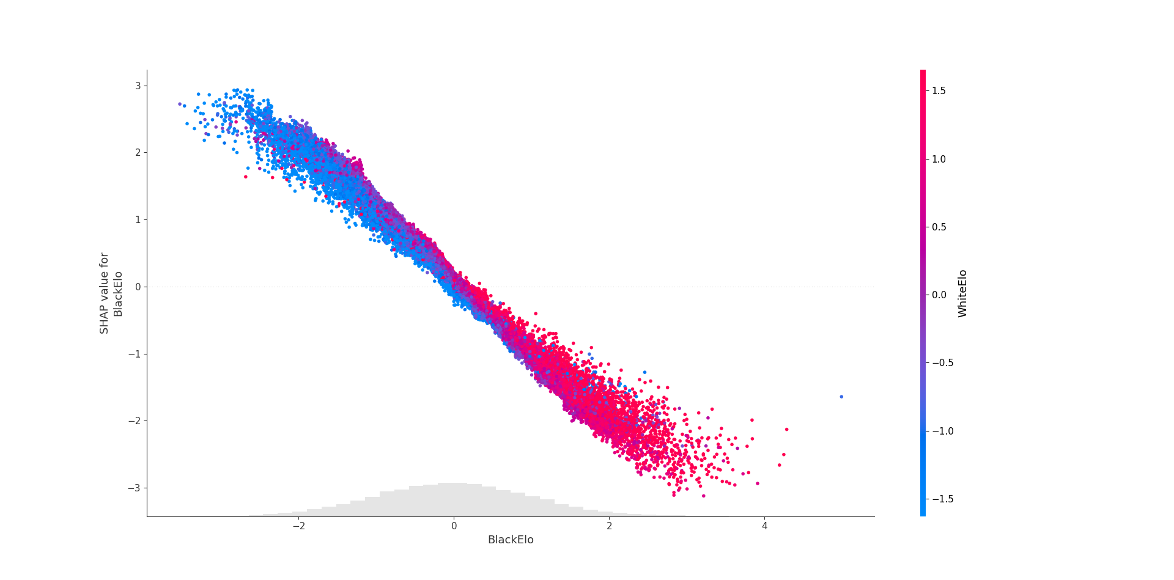

* Scatter Dependence: WhiteELO

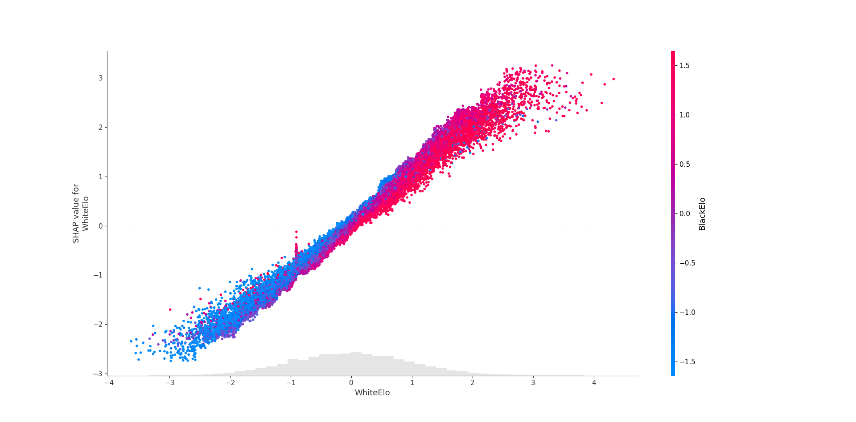

* Correlation

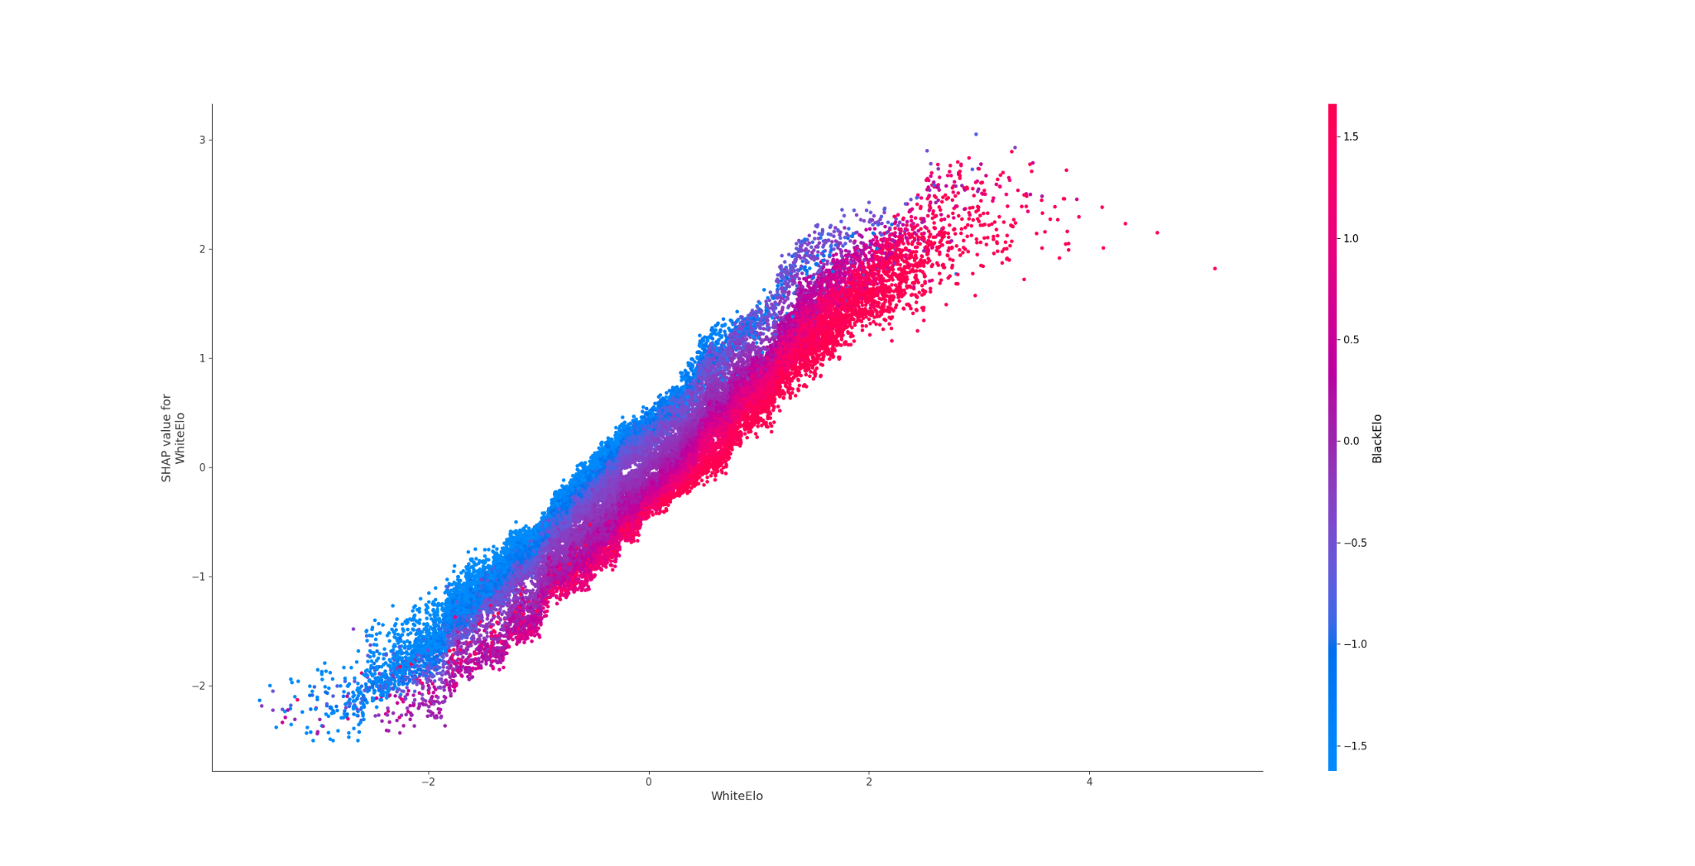

# Binary Model No Elo Difference

* **Summary Plot**

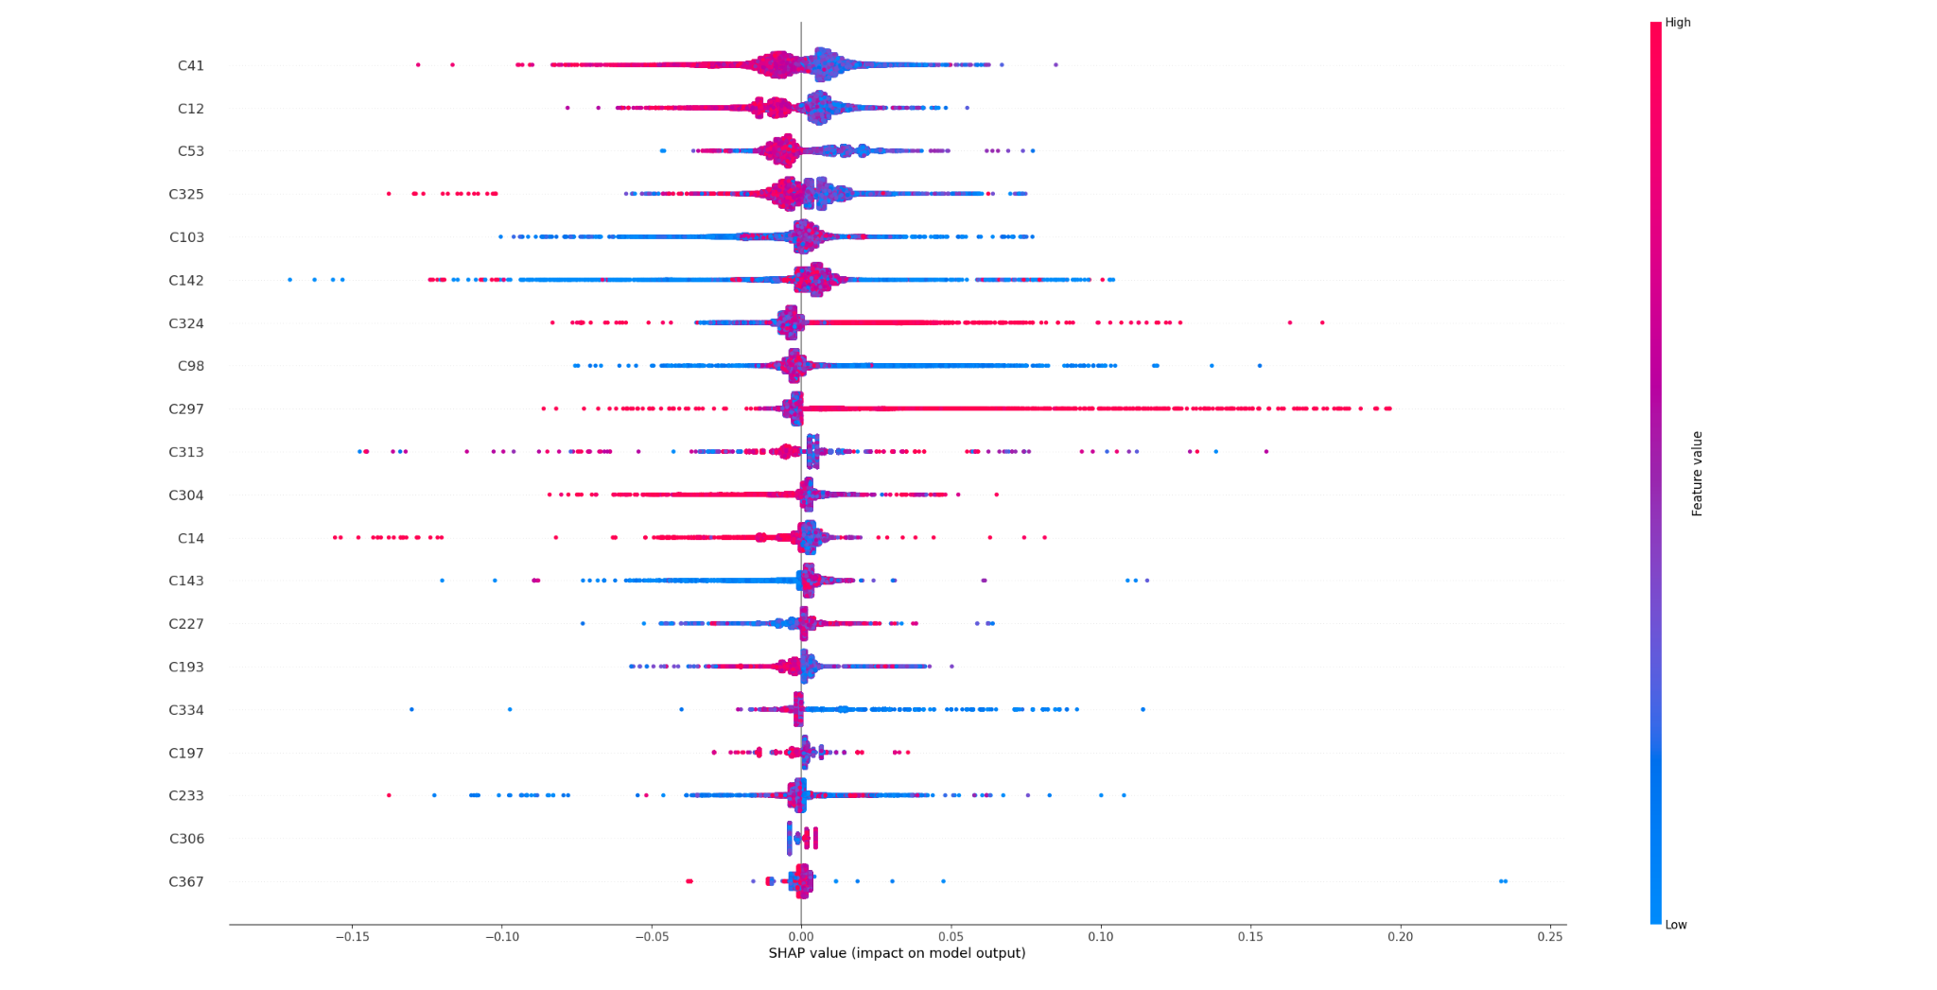

* **Decision Plot**

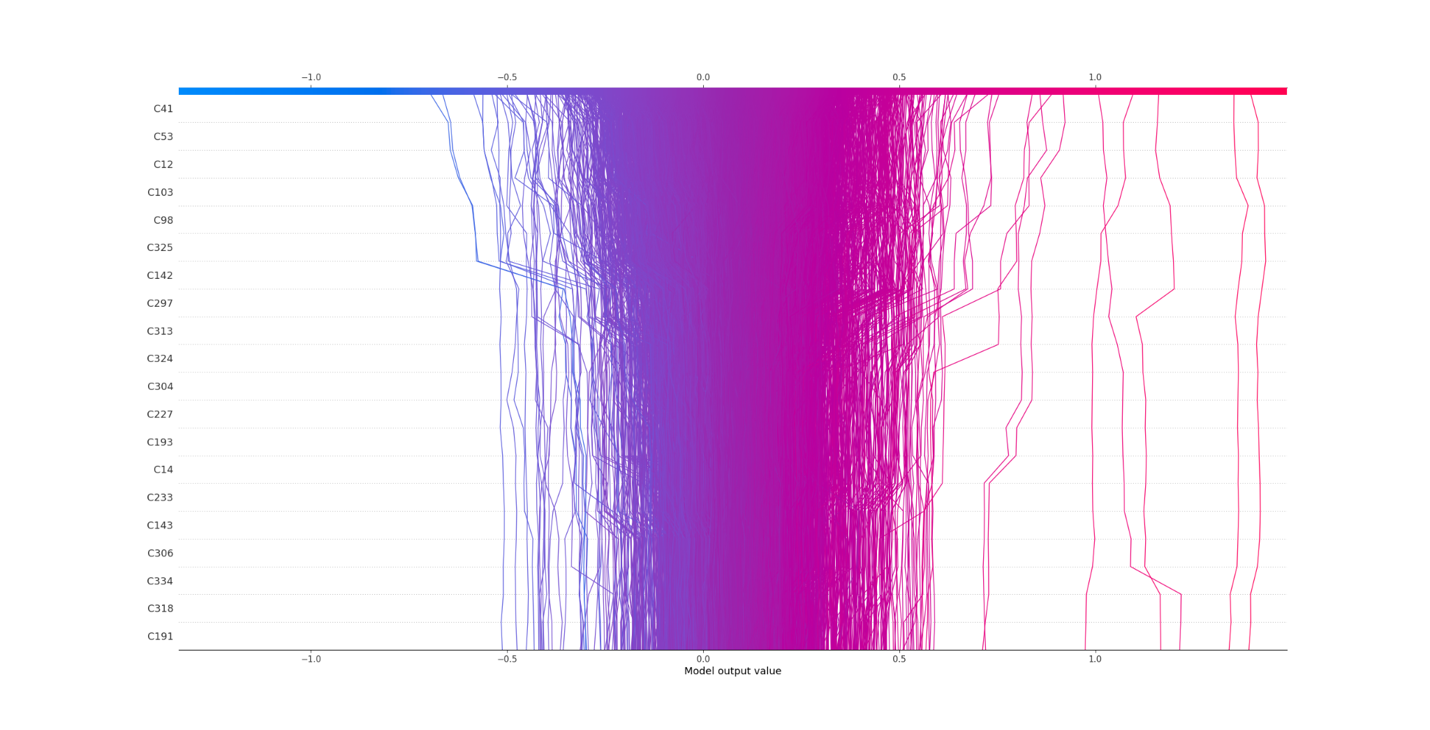

* **Confusion Matrix (Test Set)**

